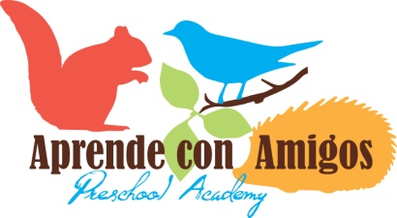
Summer Camp 2017
Overview: This summer Aprende con Amigos will run two summer camps in June, July, and August for children ages 3 to 6 years old (up to kids entering 1st grade). The first summer camp is entitled, “Up in Space” and will run for the first three weeks. The second camp is entitled, “Down in the Sea” and will run for the second three weeks. You may enroll your child for the entire six weeks, or for as many as you wish. View the attached schedule for more information about each summer camp. See you there!
Tuition Includes: A memorable week of small group instruction focused on frequently used Spanish vocabulary, high quality Spanish speaking teachers, hands-on projects, games, and activities to develop Spanish language acquisition.
Half-Day Camps (Per Week) |  | Full-Day Camps (Per Week)
Two Days | $145 | Two Days | $205
Three Days | $175 | Three Days | $250
Four Days | $200 | Four Days | $280
Five Days | $230 | Five Days | $315

Sibling Discount: Available to siblings who attend the same camp week. First child registers at regular tuition price. Second child takes $20 off Full-Day Camp tuition or $10 off Half Day Camp Tuition. Invalid with other discounts.
Enrollment/Payment Information: To enroll please submit the summer camp application for enrollment in person, via e-mail or by mail. We will confirm availability and send the appropriate paperwork and make payment for your child in the order they are received. Families enrolled in one or both summer camps will receive an informational handbook about camp prior to their start date.
Hours of Operation: Drop-off for both Half-Day and Full-Day camps is anywhere between 8-8:30am. The first day you may want to come at 8amto allow some extra time for your child to transition and get used to the drop off routine. Our first transition to whole-group will begin promptly at 8:30am. Half-Day pick up is at 12:30. Full-Day pick-up may be anywhere from 3:00-5:00pm. We feel having a window of time available for pick-up and drop-off will better accommodate families’ scheduling needs.
Lunches and Snacks: All students should pack a healthy lunch according to their dietary needs. Organic and/or all natural snacks will be provided by Aprende con Amigos in the morning and afternoon each day along with water (no juice)
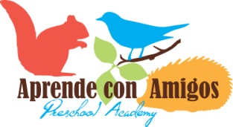
Application for Enrollment
Summer Camp

Date of Application _______________________ Child’s Date of Birth ______________________
Parent/Guardian First and Last Name ______________________________________________________
Name of Child _________________________________________________________________________
Child’s Current Age _________ Gender __________ Nickname _________________________________
Home Address ________________________________________________________________________
Primary Phone ____________________________ Secondary Phone _____________________________
Work Phone ______________________________ E-mail ______________________________________

Desired Location (circle one): Overlook Campus Irvington Campus

PLEASE CIRCLE ALL THAT APPLY:
I would like my child to attend the following week(s):
Up in Space |  | Down in the Sea
Week 1 | July 3rd – 7th No Camp on 4th | Week 4 | July 24th – July 28th
Week 2 | July 10th – 14th | Week 5 | July 31st – August 4th
Week 3 | July 17th – 21st | Week 6 | August – 7th – August 11th

I would like my child to attend (Circle one):
Full-Day (8am to 5pm) Half-Day (8am-12:30pm)
He days I would like my child to attend are:
Monday Tuesday Wednesday Thursday Friday

Signature of Parent or Guardian __________________________________________________________
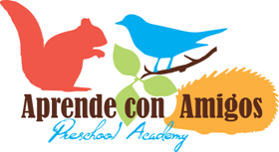
Summer Camp
At Aprende con Amigos our summer camps ensure children “learn with friends” through an exciting, well-balanced and active learning environment. You may enroll your child for all eight weeks or as many weeks as you wish. Each day students have opportunities to explore in our three learning areas: art/music, math/science, and language arts/social studies. Each week students will be involved in science experiments, art projects, cooking sessions, dramatic play, creative writing, shared reading, and more! Whether your child is being exposed to Spanish for the first time or is completely fluent, there will be something for everyone at Aprende con Amigos. See you there!
Up in Space – First Three Weeks
Our first camp is called “Up in Space” and will focus on building both basic Spanish vocabulary such as colors, shapes, and number as well as more focused space vocabulary through fun, hands-on experiences. During this camp, students will have the opportunity to conduct experiments with light, design works of art using solar energy, create constellations, and have fun creating a space station to pretend in!
Down in the Sea – Second Three Weeks
Our second camp is called “Down in the Sea” and will focus on building basic Spanish vocabulary and simple sentence structures focused on the sea. Child will have fun making fish prints, creating sand castle works of art, conducting sink or float experiments, and more! The table below provides more detailed information for each week of camp.

Up in Space | Week | Dates | Description
 | 1 | July 3-July 7  The Sun and Moon | Children will learn Spanish colors, shapes, letters, numbers and opposites as they have fun manipulating light and shadow.
 | 2 | July 10 – July 14  Our Planets | Children will learn Spanish shapes, number, colors, and shapes by learning about the planets and their properties.
 | 3 | July 17 – July 21  Rockets & Spaceships | Children will learn Spanish numbers, shapes, and simple describing words by constructing rockets and spaceships!
Down in the Sea | 4 | July 24 – July 28  At the Beach | Children will learn color, size, and describing words and numbers through fun sorting activities and games.
 | 5 | July 31 – August 4  Sea Animals | Children will learn color, shapes, body part vocabulary by acting out stories and playing sea animal games.
 | 6 | August 7 – August 11  Water & Life Cycles | Children will learn water cycle and animal life cycle vocabulary by observing and recording experiments and projects.

