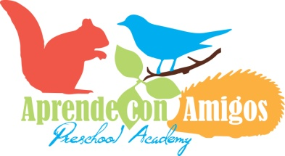

2019 Summer Camp Application Irvington School

Date of Application _____________________

Parent/Guardian First and Last Name ______________________________________

Name of Child ________________________________________________

Date of Birth ___________________________________

Grade for the upcoming school year ________________________________

Email __________________________________________

I would like my child to attend the following week(s) at the Irvignton Site:

My five Senses Fairy Tales and Fables

Additional Week at Overlook Site: June 24th-28th

Week 1: July 1st-5th (no camp July 4th) Week 4: July 22nd- 26th

Week 2: July 8th-12th Week 5: July 29th- Aug 2nd

Week 3: July 15th-19th Week 6: Aug 5th- 9th

I would like my child to attend:

Full Day (8am-5pm) Half Day (8am-12:30pm)

On the following days:

Monday Tuesday Wednesday Thursday Friday

Summer Camp Weekly Tuition
Half |  | Full
2 Days | $160 | 2 Days | $225
3 Days | $190 | 3 Days | $270
4 Days | $215 | 4 Days | $300
5 Days | $250 | 5 Days | $340

